Details for the Semi-Annual (Oct) Parts Price update process in NAXT

Contents

Parts Semi-Annual (Special October 2021) Pricing 2

**Friday 24th** 2

**Saturday 25th** 2

# Parts Semi-Annual (Special October 2021) Pricing

Steps for loading the Special Oct Pricing on the afternoon of 25th Oct 2021.

Noting this could take 8-10 hours.

## **Friday 24th**

1. **Put notification on Fetch for Outage Window – DONE!**
   1. **From 2pm Sat 25th to Noon Sun 26th**
2. **Scheduled/Request NAXT back-up is taken on Saturday afternoon, prior to price load – DONE!**

## **Saturday 25th**

1. **Disable User Access via Citrix**
2. **Pause/Stop other batch jobs (especially the Parts Daily!)**
   1. Batch Jobs “COMAX – CAT Parts Pricing Daily job.”, put the status to “Withhold”

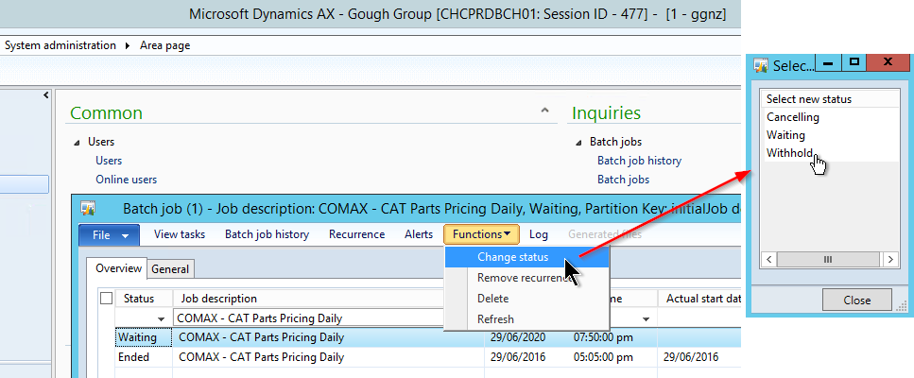

1. **Confirm backup for Production NAXT have completed**
2. **Check no other jobs/process is running**
   1. **DWH – Confirm with Kunal**
      1. **Remote onto cclprdbi01**
      2. **Open “services”**
      3. **Stop the service “WhereScape prod_scehdule_01”**

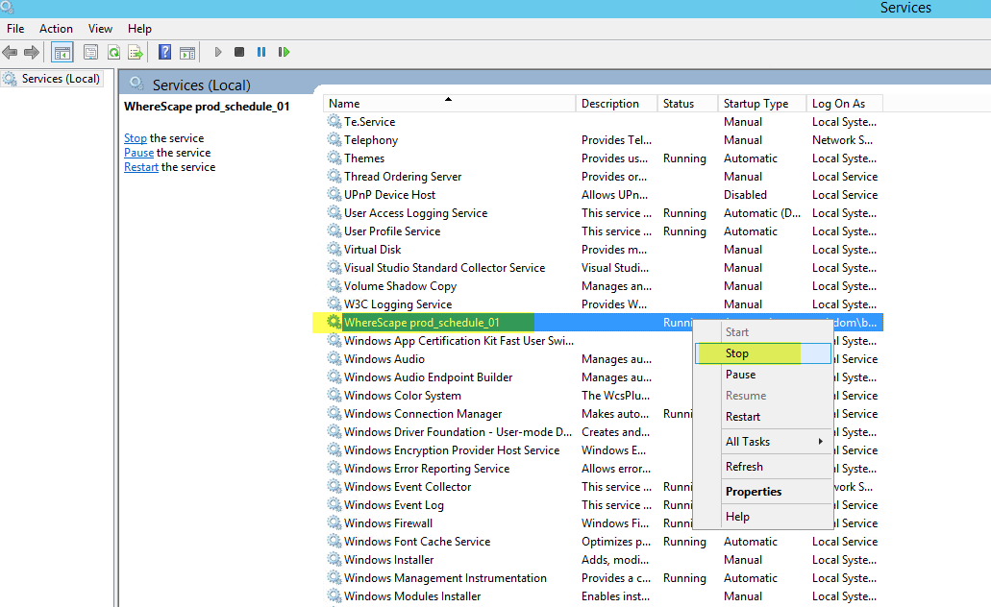

* 1. **Check no NAXT Batch Jobs are executing**

1. **Change Inbound file path for Parts Daily Price** 
   1. In COMAX\Setup\Communication… change the Inbound file path to…

**\\COMAXPROD\COMAX\PartsDailyPricing\In**

(NB: to ensure we do not pick up the daily file, generally received in the late afternoon Mon - Sat)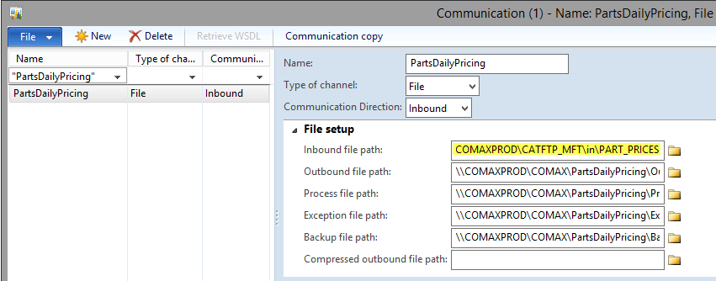

1. **Put Semi-annual file in folder for loading** 
   1. Copy the July 2021 Parts Semi-Annual Price file from here:

\\ad.ggh.co.nz\Emerge\Workstreams\Interfaces\CAT Files\2021 Semi-Annual Price Updates\2021 October Special CAT Parts Pricing\BERY1755

To here (from step 5): **\\COMAXPROD\COMAX\PartsDailyPricing\In**

1. **Confirm “Use threads” is enabled**
   1. In Comax – Setup – Interfaces, on “IFCatPRC” interface, go to Interface Documents…

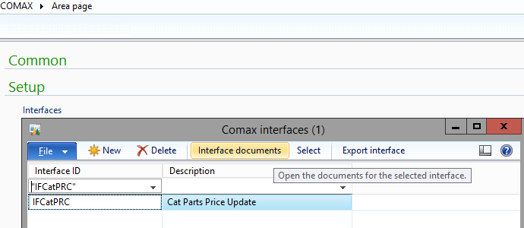

* 1. In the Setup Tab, ensure “Use threads” is ticked/enabled

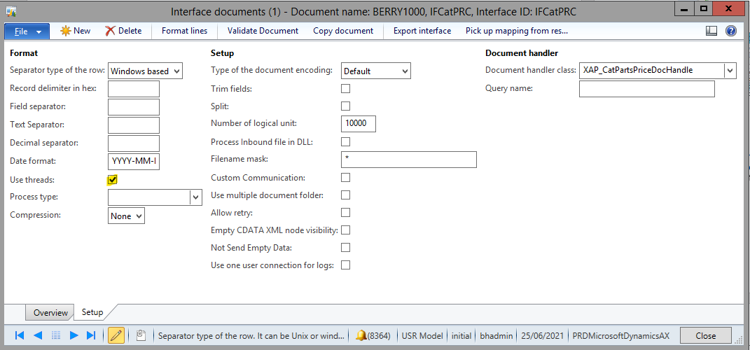

1. **Turn off all but one AOS (batch)**
   1. **PowerShell**
2. **Clear all usage data**
3. **Run Parts Pricing Job - BERY1000**

In COMAX module, Periodic- Import/Export

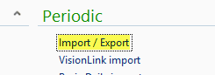

**General Tab**, in Document name select BERRY1000

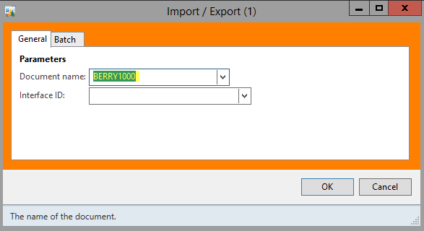

**Batch Tab**, tick “Batch Processing”, enter an applicable Task Description (i.e. Oct 2021 Parts Special Price), and Batch Group Comax

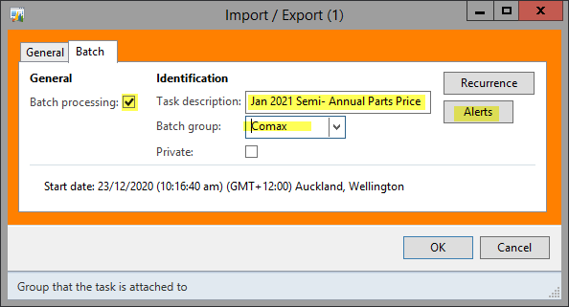

**Alerts**, disable all (if not thousands of emails will be generated and can impact performance)

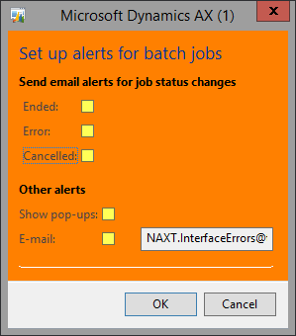

Then click “**OK**” (on Alerts and Import/Export windows) to kick off the job

1. **Monitor Batch Job and then COMAX Queues and Log**

Once job kicks off, it will create two entries in Batch Jobs, this will pick up and split the file.

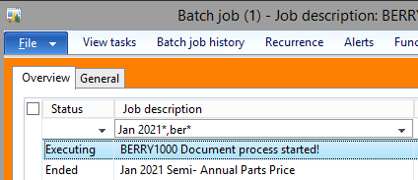

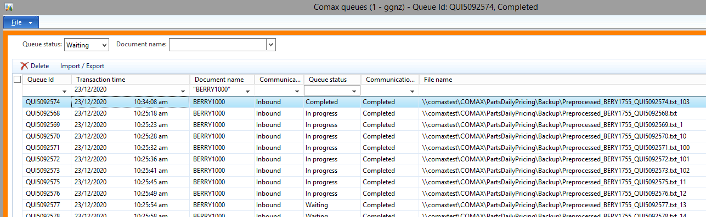

1. **When done, check logs for any errors**
   1. Expect to see things like 1004 and/or 1005 informational entries, which just indicate prices that have had daily updates since the semi-annual file was produced.

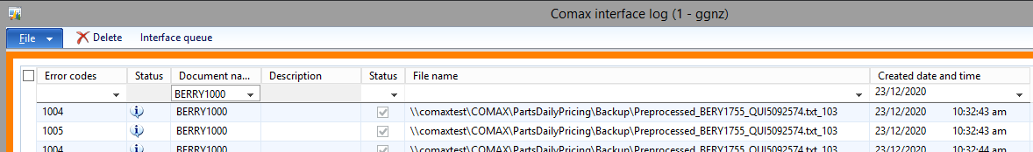

* 1. Any other errors, review and advise
  2. Spot check a few parts prices in NPR (including some with core pricing)

1. **Turn back on other AOS servers**
2. **Start the “WhereScape prod_schedule_01” service on cclprdbi01 server**
3. **Re-enable User Access via Citrix**
4. **Change Inbound file path for Parts Daily Price** 
   1. In COMAX\Setup\Communication… change the Inbound file path back to…

**\\Comaxprod\catftp_mft\in\PART_PRICES**



1. **Put scheduled Jobs back** 
   1. **i.e Daily Parts Price update job back to “Waiting” (reverting from above)**
      1. In Batch Jobs, on job “COMAX – CAT Parts Pricing Daily job.”, put the status to “Waiting”
2. **Update Andy’s Extract XLS and advise when completed / send out comms – NB: This will not be on the weekend**
   1. For Kurt to action

**PARTS IS DONE!**